## Team Roles

Product Owner & Developer - [Joseph Nyangwechi](mailto:jnyangwe@tamu.edu)

Scrum Master & Developer - [Sindhuja Reddy Kamidi](mailto:sindhujareddykamidi@tamu.edu)

Developer - [Suraj Shamsundar Jain](mailto:surajsjain@tamu.edu)

Developer - [Sankrandan Loke](mailto:lokesankrandan@tamu.edu)

## Customer meeting date/time/place

Date: Weekly Every Tuesday

Time: 4:45pm - 5:15pm

Place: Zoom <https://tamu.zoom.us/j/7404683541>

## Summary

We will be implementing the "privilege walk". Example can be found [here](https://www.eiu.edu/eiu1111/Privilege%20Walk%20Exercise-%20Transfer%20Leadership%20Institute-%20Week%204.pdf). The client of the project is Dr. Shawna Thomas, a Computer Science professor here at TAMU. The first problem we would be solving with the privilege walk is that many times people don't want to stand out when doing the "Privilege walk". They might feel embarrassed or shy and therefore might be unwilling to participate or be honest in this activity. In addition the Privilege walk needs to be done in a big open space and you cannot do it when participants are physically located in different areas.

Our solution will be creating an online tool that facilitates doing the privilege walk. This tool would anonymize participants so that they don't feel singled out while providing an instructor the anonymized statistics. The online tool will also enable doing this activity with participants not located in the same physical space.

Pivotal Tracker: <https://www.pivotaltracker.com/n/projects/2556087>  
Github Link: <https://github.com/Privilege-walk/privilege-walk>

## User Stories

User Story 1

**Feature: Anonymize participants while doing the privilege walk**

As a privilege walk participant

So that I don’t feel singled out while doing the privilege walk.

I want my privilege walk answers to not be visible to other people while I’m doing the privilege Walk.

User Story 2

**Feature: Event short description and option to join**

As a privilege walk participant

So that i understand the event.

I want to see a short description of the event before i join the event.

User Story 3

**Feature: Display the questions**

As a privilege walk participant

So that i can join the event and participate

I want to see the question description and the options for answers when the event is live.

User Story 4

**Feature: Show participants anonymized privilege walk results**

As a privilege walk participant

So that I know how long i need to wait for the next question.

I want to see the number of participants yet to answer the question as an indication of waiting time to get to next question.

User Story 5

**Feature: Show the results of privilege walk after the event**

As a privilege walk participant

So that I know the results and my position after the event.

I want to see the my position among the participants and statistics of my privileges.

User Story 6

**Feature: Create new events**

As a host of a privilege walk event

So that my event attendees can participate in it.

I want to create an event on the hosts dashboard and have it stored in the database.

User Story 7

**Feature:** **Add and customize questions in the events created**

As a host of a privilege walk event

So that my event attendees can answer them.

I want to be able to add, remove, and edit the content of the questions using the host-side dashboard.

User Story 8

**Feature: Add points to the answer options**

As a host of a privilege walk event

So that attendees can move forward or backward in the line.

I want to be able to set points to each of the options in the questions that determine the movement of the users choosing that option as an answer.

User Story 9

**Feature: Host the event live**

As a host of a privilege walk event

So that the attendees can connect to it.

I want the attendees to be able to scan the QR code, join the event, and participate in the anonymous privilege walk.

User Story 10

**Feature: View the live answers and analytics during the event**

As a host of a privilege walk event

So that I know the new attendees positions based on their answers

I want to view a graph showing the number of attendees on each line

User Story 11

**Feature: View the results of the event**

As a host of a privilege walk event

So that I gain insights about the diversity of the participants in the activity

I want to view the final results of the activity in the form of animation and charts

User Story 12

**Feature: Export results of the event**

As a host of a privilege walk event

So that I can access the results of the activity even after it ends

I want to be able to download data in the form of charts and excel

## Lo-fi prototype: (these screens are subjected to change as per the client’s suggestions)

### Participant Portal:

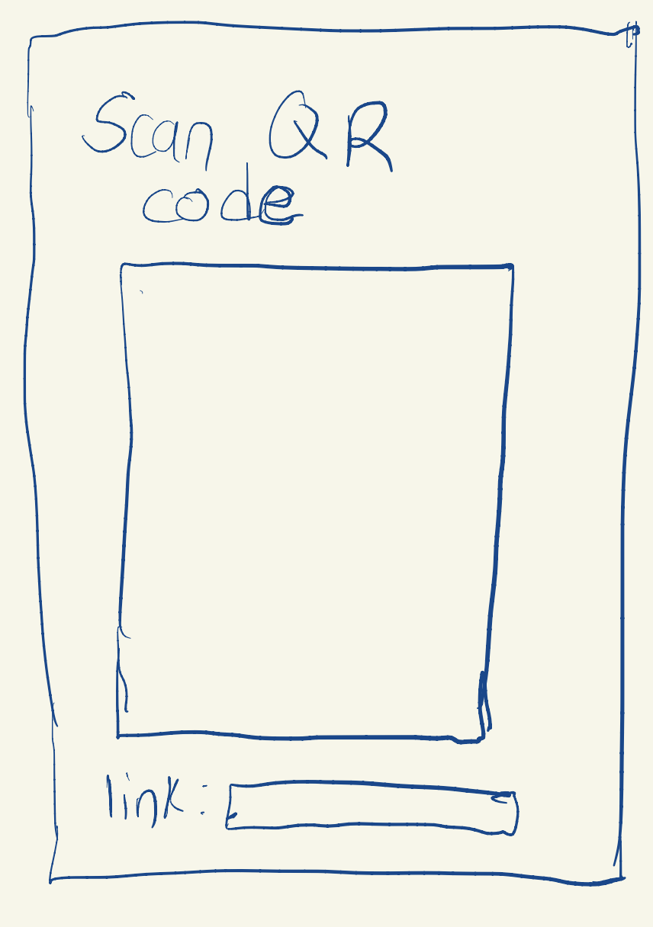

Introduction screen:

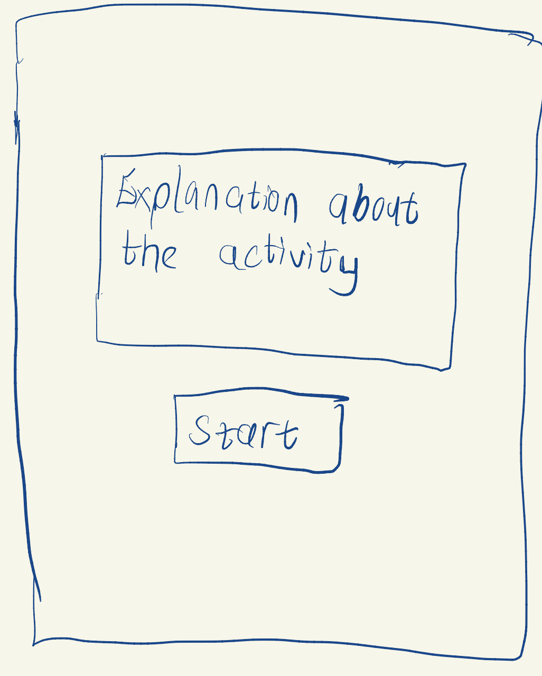

Live Event Questions screen:

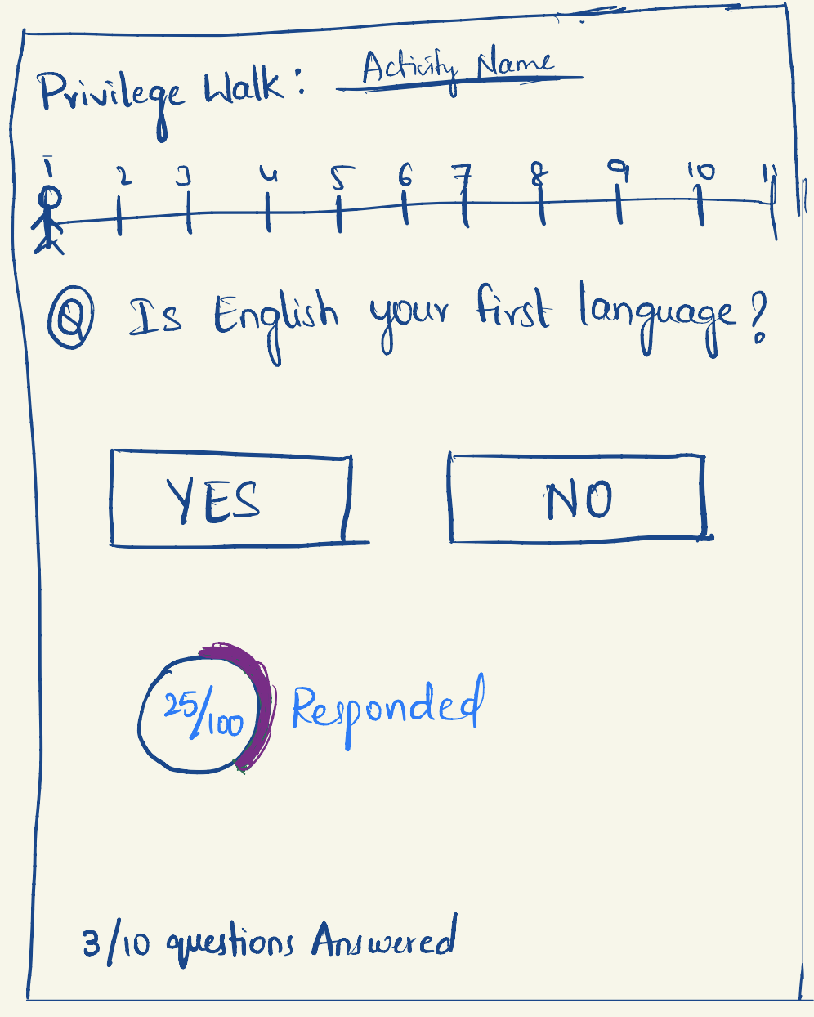

Completion of event screen:

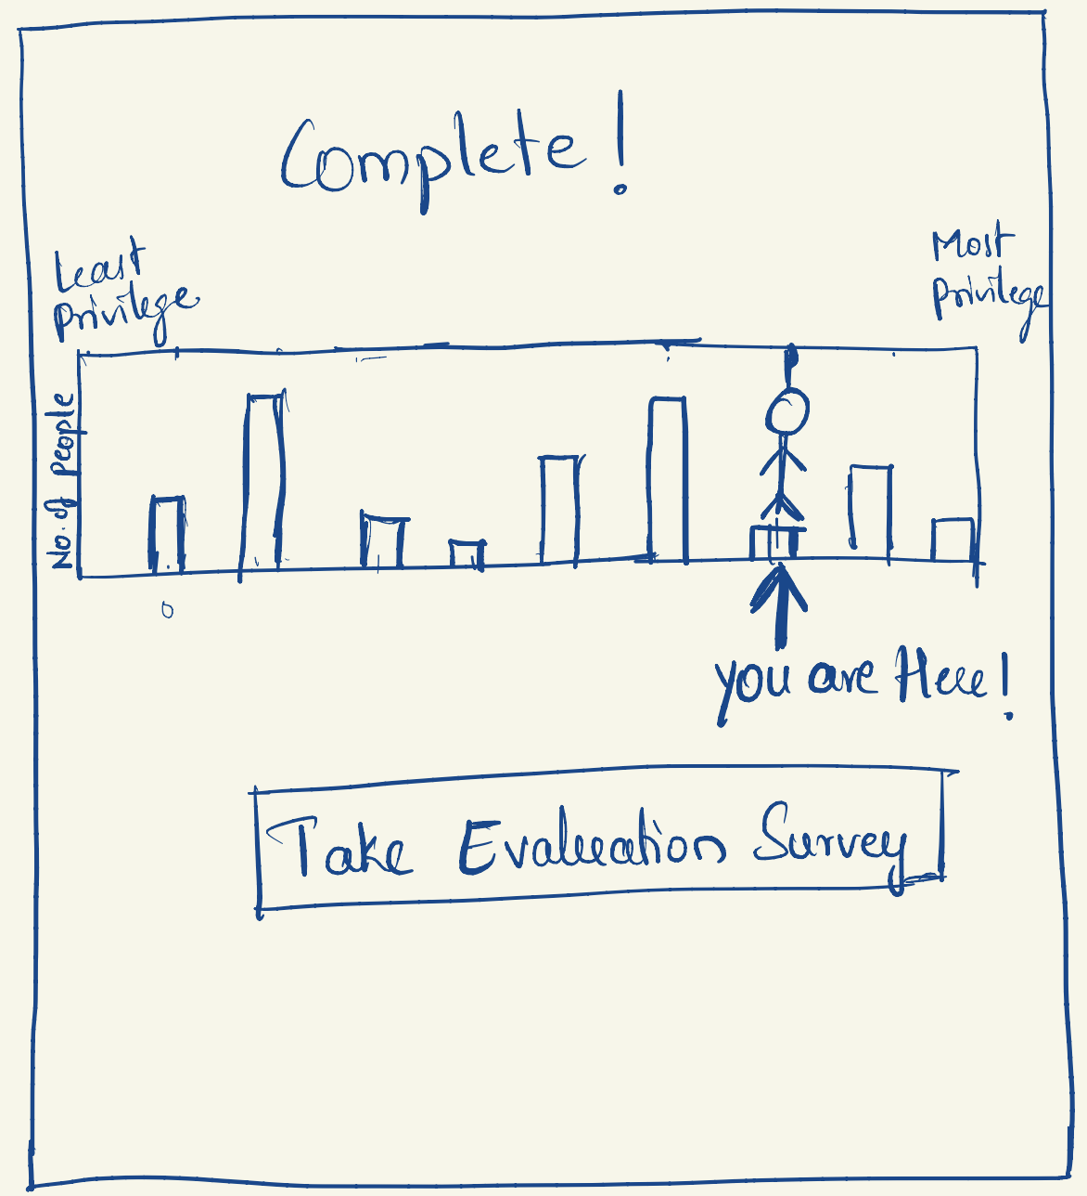

### Host portal:

Home screen:

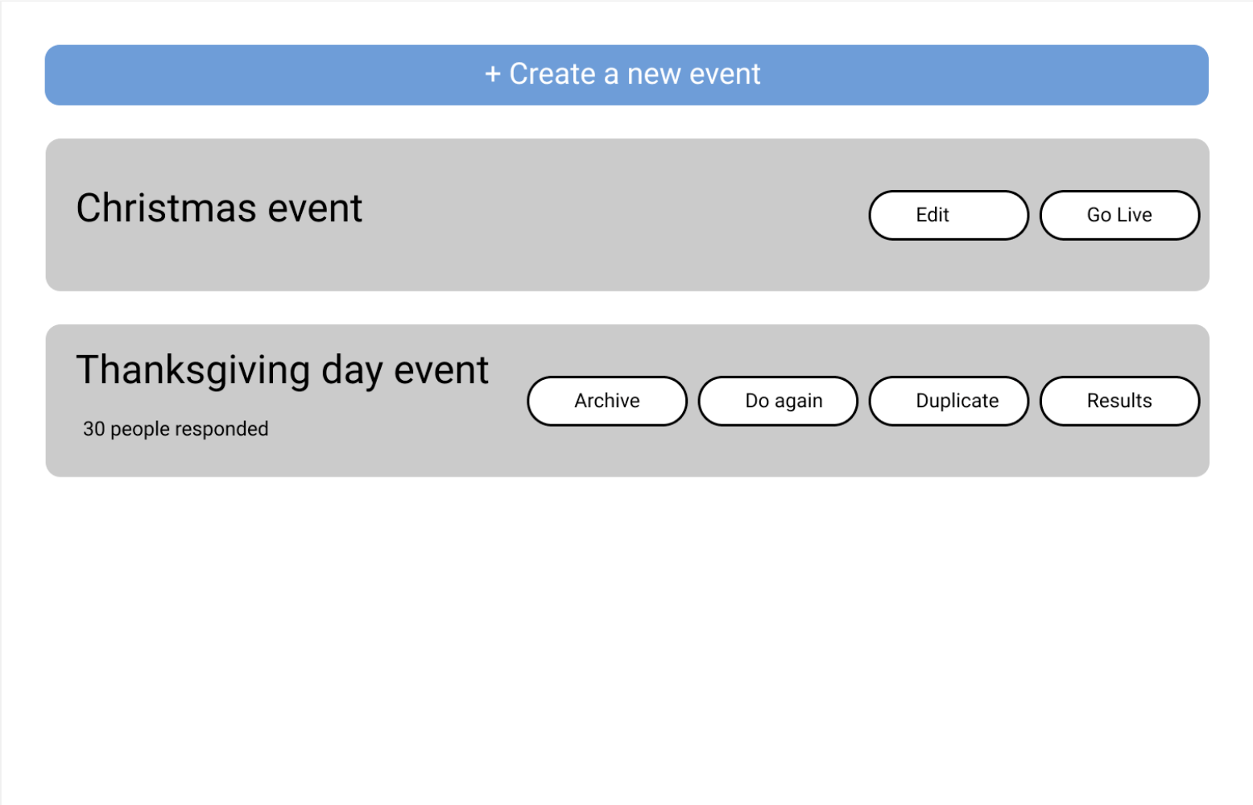

Event page screen:

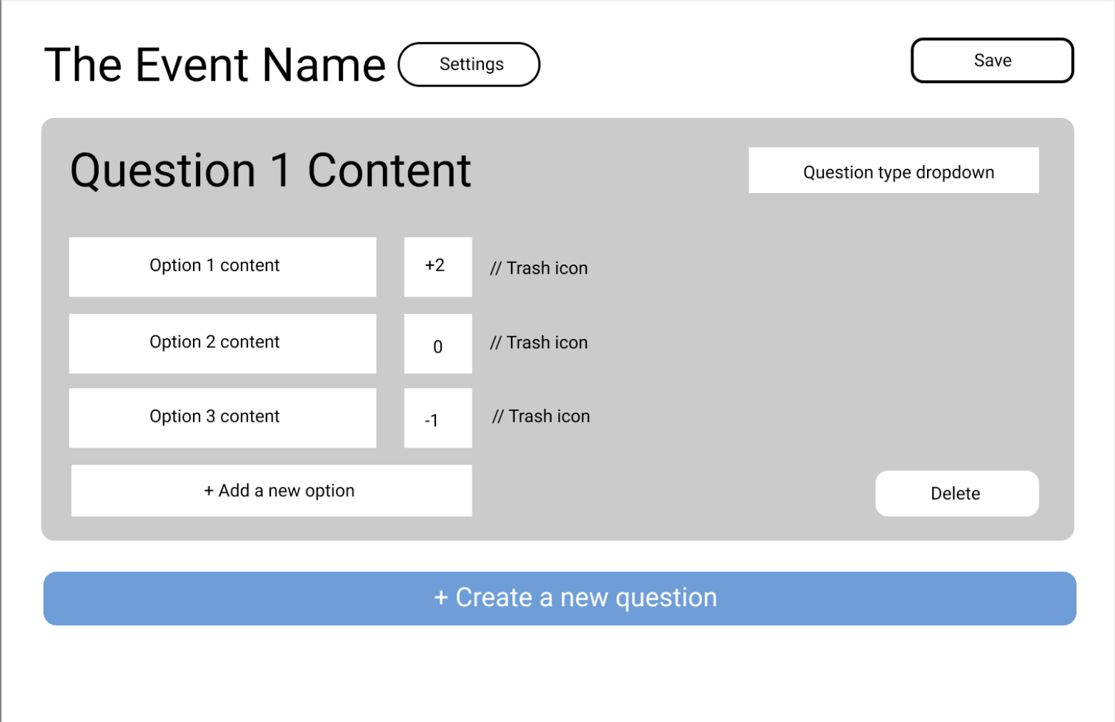

Event QR code screen:

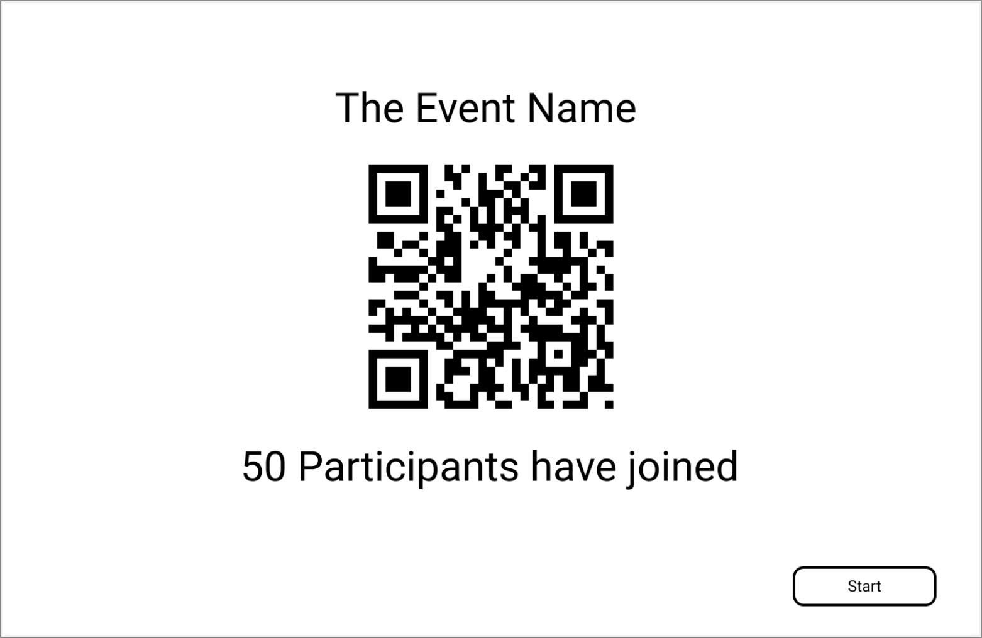

Live event screen:

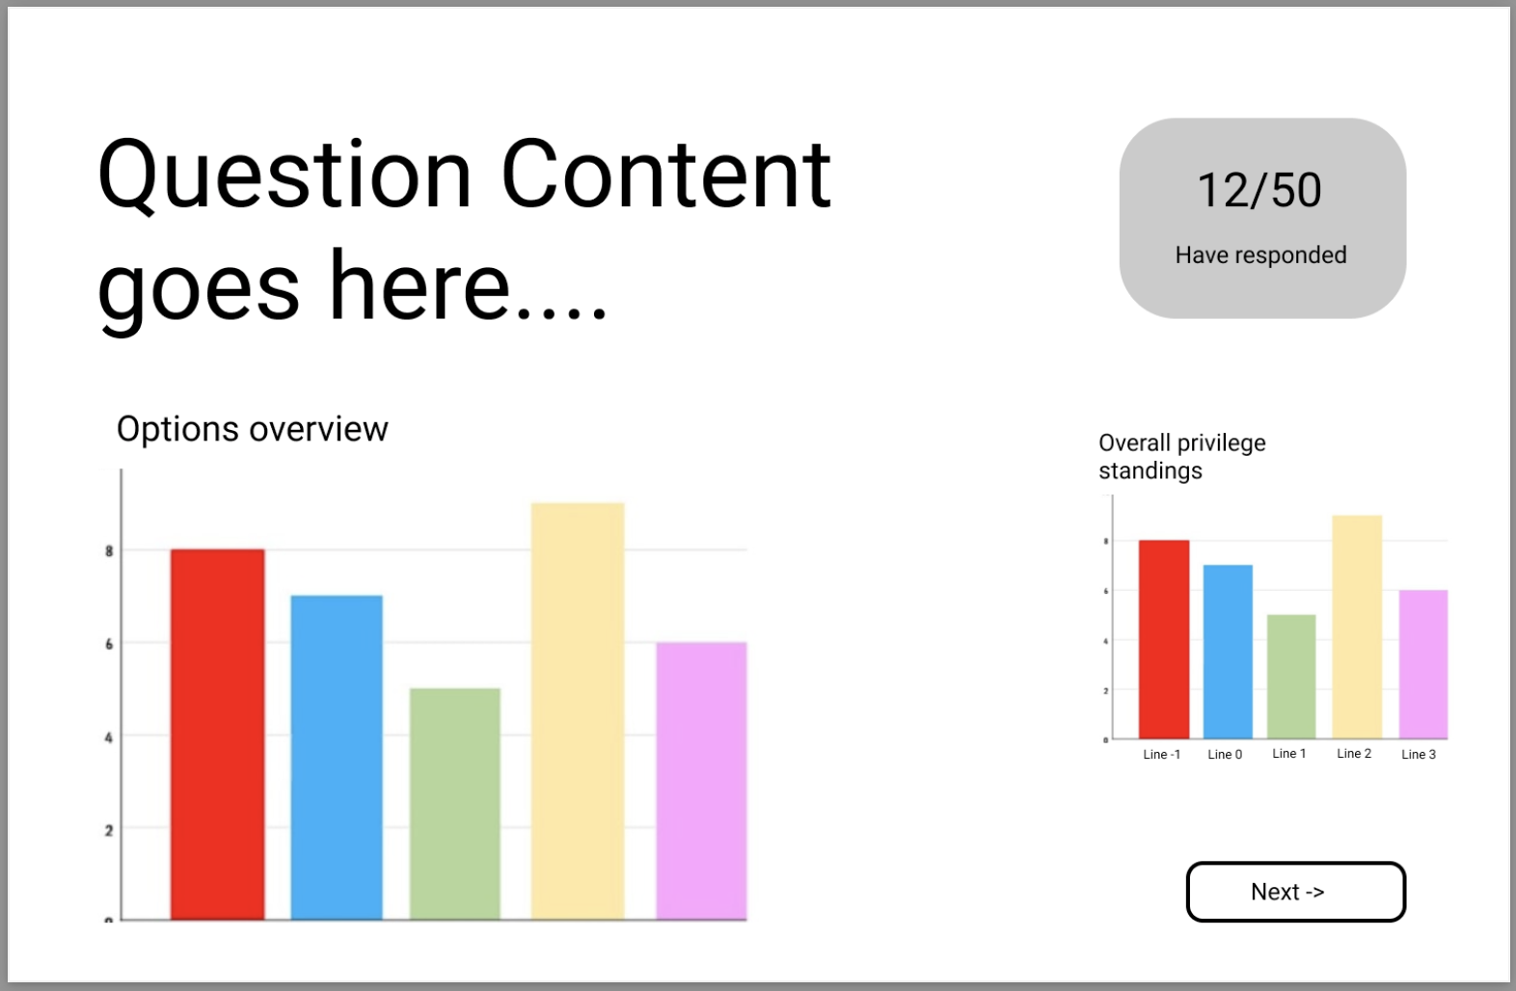

Event summary screen:

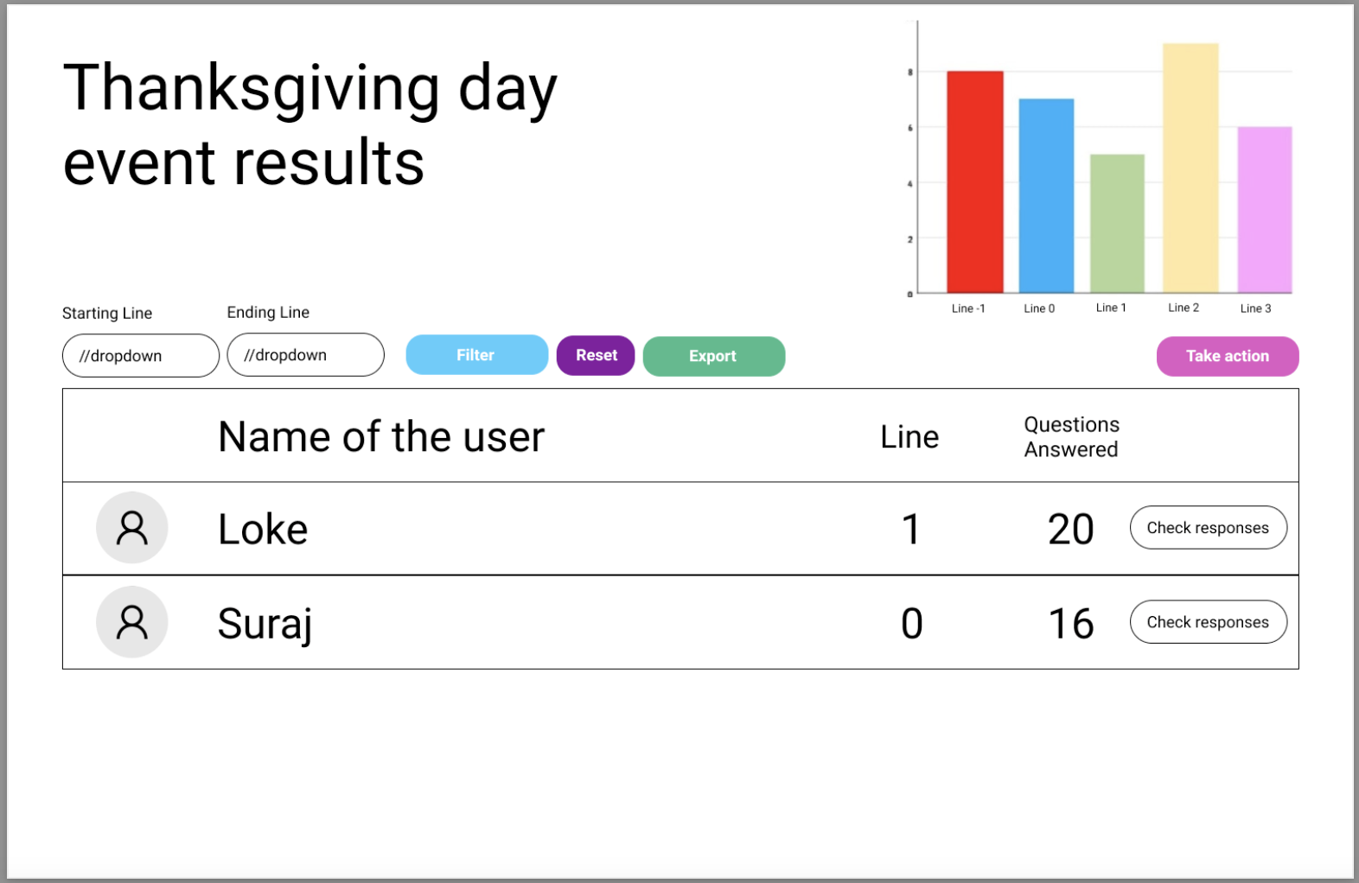

# Changes to the screens as discussed in the client meeting:

​​

**User Side**

## **Screen 2**

* The user has to know what will be done with the data, so display it.

## **Screen 3**

* Programming of the scale whose numbers will be changing dynamically
* Don't number the lines, a number like "-2" might demotivate someone
* "Yes" or "No" is much simpler and be mentally good, giving a feeling of unbiases
* Timer might be good, but let the host decide

## **Screen 4**

* Make the bar charts centered horizontally (going left and right cuz they might make more sense when the number of lines are more)

# **Host Side**

* Come up with something to combine the data after duplication of events.
* Change the “Do again” to “Resume” or “Restart” to avoid confusion.

Settings:

* Include data anonymization, data erasing policies, data encryption
* Make them known to the user